MARKET ANALYSIS REPORT FOR NATIONAL CLOTHING CHAIN

An online national clothing chain needs your help creating a targeted marketing campaign. Sales have been flat and they want to lure lost customers back. They want to advertise specific products to specific customers in specific locations, but they don’t know who to target. They have three products in mind:

* Shirt: $25
* Sweater: $100
* Leather Bag: $1,000

ANALYSIS RESULTS

1. What is the correlation (R2 value) between sales and income?

The correlation between sales and income is 0.78 which shows that there is a strong correlation between sales and income. The last 6 months purchases of customers is used to predict their income.

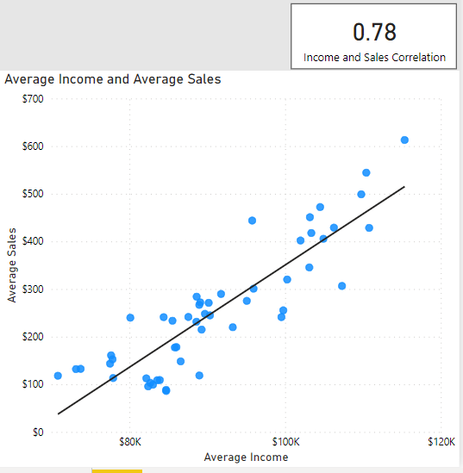

1. What is the correlation (R2 value) between customer ratings and product return rate?

The correlation between customer ratings and product return rate is 0.69, this indicates a moderate correlation between customer ratings and product return rate.

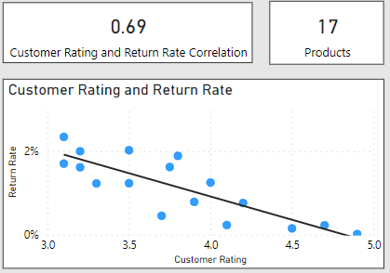

1. What are the linear regression formulas to predict customer income from customer sales?

X = (-722.14 – Y)/-0.01

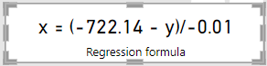

1. Which customer do you predict has the highest income?

The customer with the highest predicted income is Jon Little with a predicted income of $597,214.

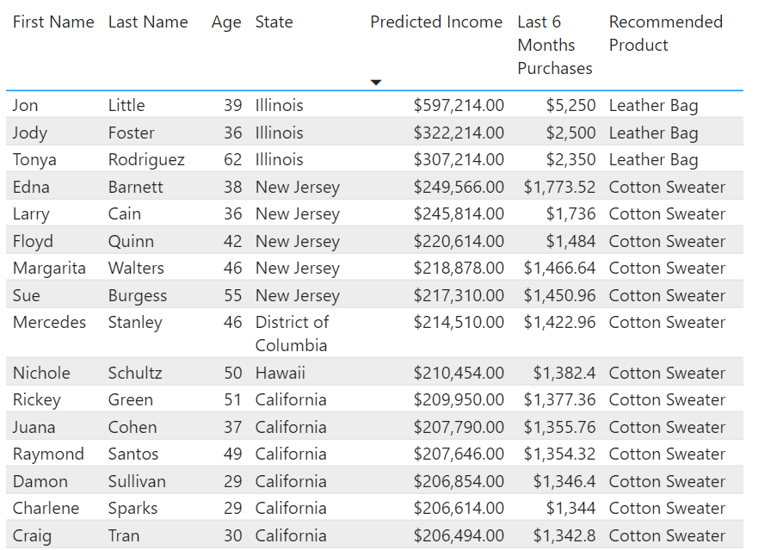

1. Which product will be advertised the most?

Spring T-shirt will be advertised the most to 707 customers.

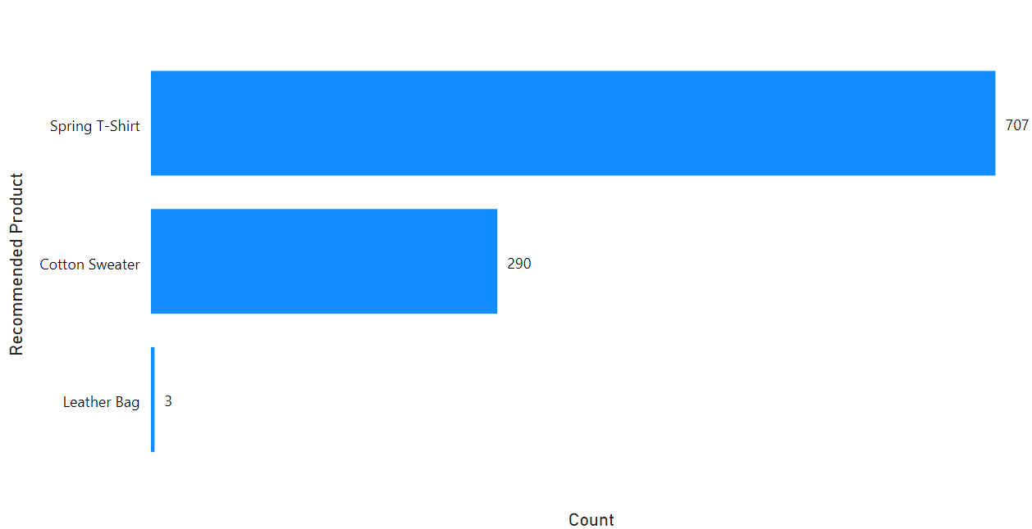

CONCLUSION

* Most customers fall into an income category of $75,000 - $150,000

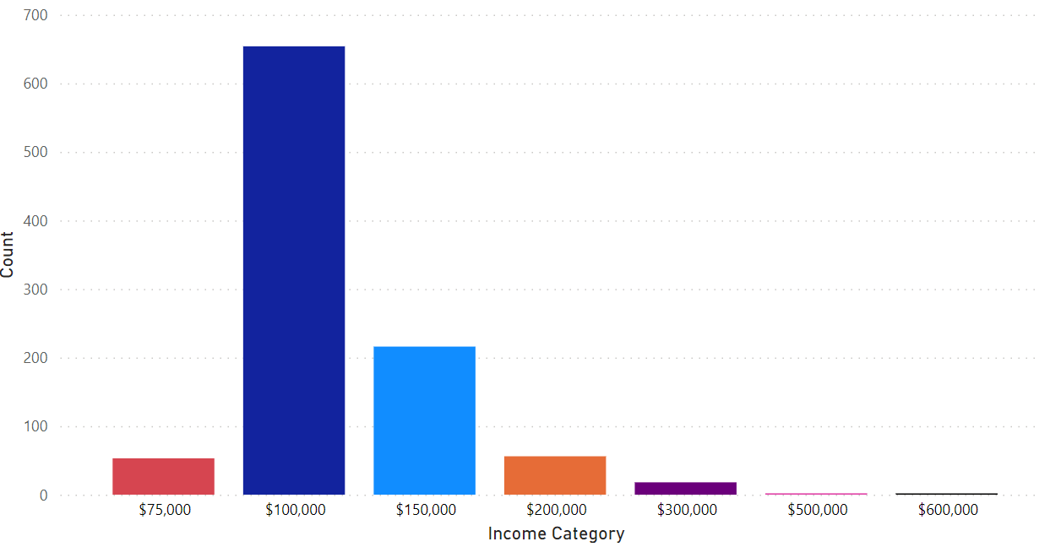

* A good number of the population work in Educational services, healthcare and social assistance industry

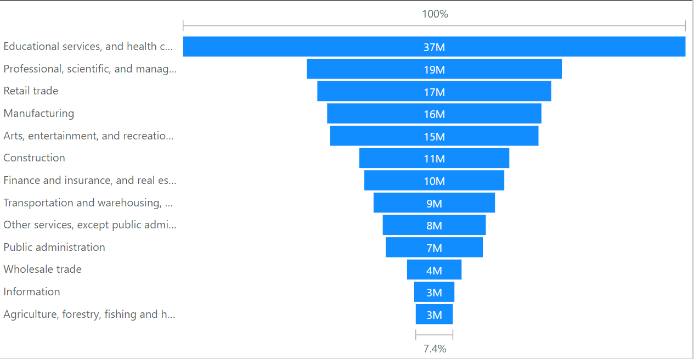

* Some states have low customer base when compared with the population

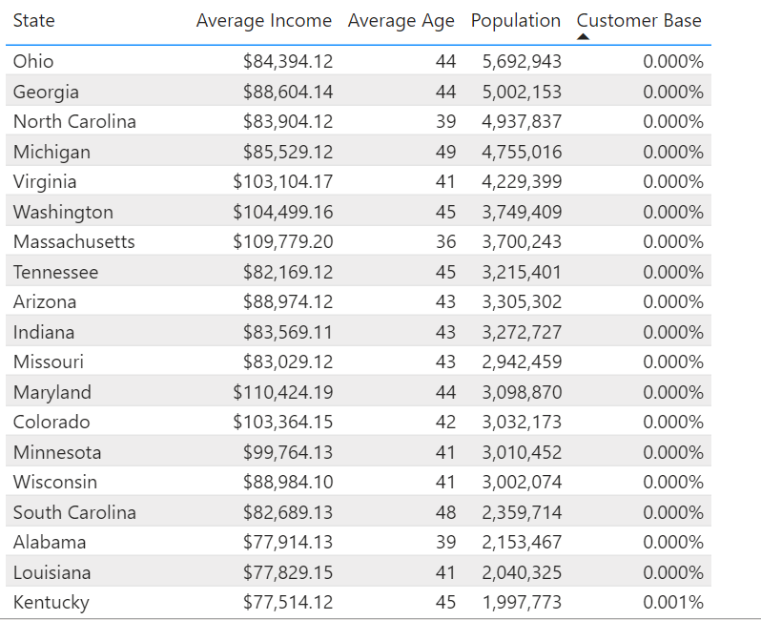

* Sales picked up from September to December but dropped from the beginning of the year till March.

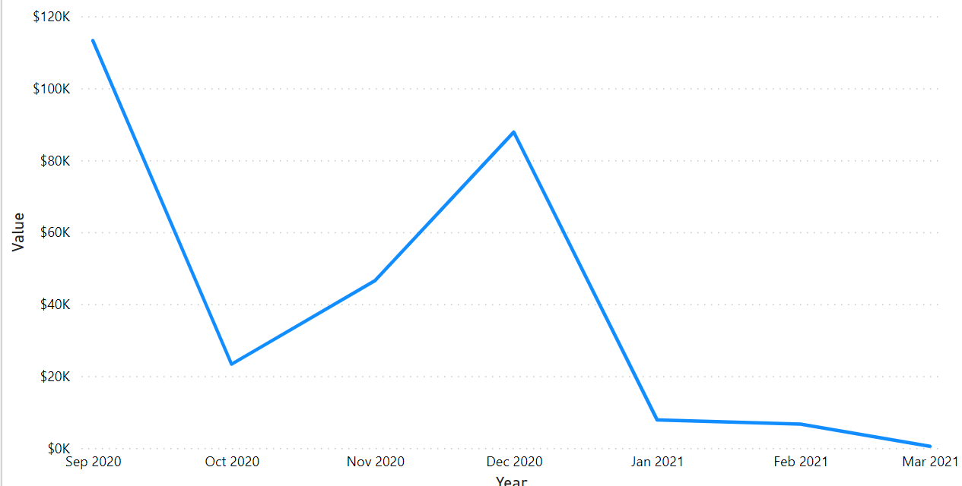

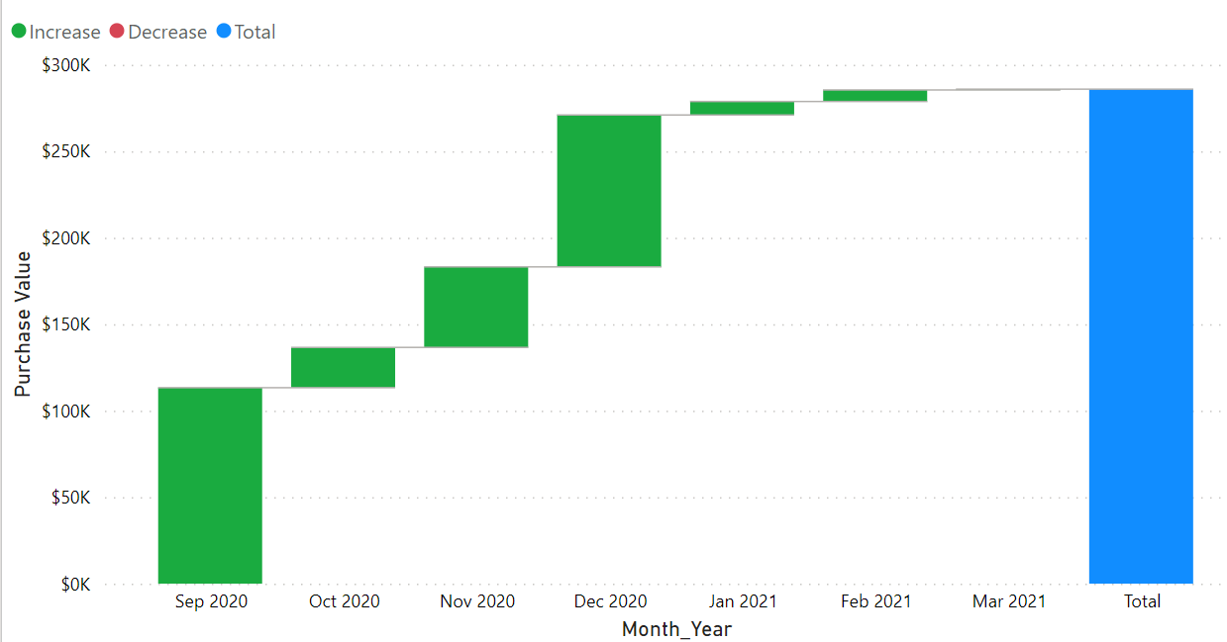

* Out of a total purchase value of $285905.10, California had the highest sales with a value of $64,331.81

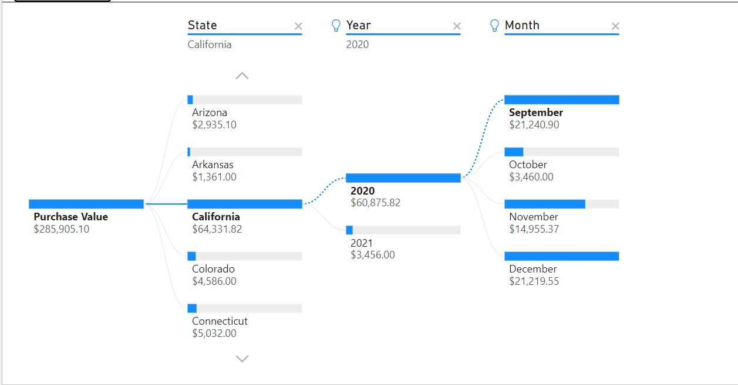

RECOMMENDATIONS

* More marketing efforts should be put into acquiring customers in states with very low customer base
* Ads should be targeted at people who work in Educational services, healthcare and social assistance industry
* A survey should be carried out to discover why customers leave poor ratings for some products and where improvements can be made in such products.
* Additional data is required to determine why sales dropped from January to March of 2021

SCREENSHOTS

